APPENDIX A

Survey on Hurricane Warning Effectiveness

Charles Cockcroft
EVSS 691

June 27, 2000

A Publication of the University of Charleston pursuant to an Outreach Program Agreement with the University Corporation for Atmospheric Research and pursuant to the National Oceanic and Atmospheric Administration Award No. NA97W0082 (Sub-award number UCAR-S00-22461)



Section 1. Socio-Economic Factors
1) Your gender is:
a) Male
b) Female
2) Your age is:
a) 18-25
b) 26-35
c) 36-45
d) 46-55
e) 56-65
f) 66 and above
3) Your race is:
a) Caucasian
b) African-American
c) Hispanic
d) Native-American
e) Asian/Pacific Islander
f) Other (please specify)___________.
4) What is your highest level of education completed?
a) Grade school (8th grade)
b) High school (12th grade)
c) Undergraduate degree
d) Graduate
5) What is your household income?
a) Less than $ 25,000/year
b) $25,000-49,999
c) $50,000-74,999
d) $75,000-99,999
e) above $100,000
6) Are you married?
a) Yes
b) No
7) Number of dependent children in your household? ____
8) Number of dependent adults in your household? ____
9) Do any members of your household have a physical or mental disability/impairment?
a) Yes
b) No
10) If you answered yes to # 9, how many disabled/impaired people live in your household? _____
11) If you answered yes to # 9, would you require assistance during evacuation of these mentally/physically challenged people?
a) Yes
b) No
12) Do you own/lease an automobile?
a) Yes
b) No
13) Would lack of money restrict your ability to evacuate in the event of a dangerous hurricane?
a) Yes
b) No
14) How long have you lived in the tri-county area (Berkeley, Charleston and Dorchester Counties)? __________years
15) Would the lack of shelters for your pet/pets prevent your evacuation during a hurricane warning?
a) I don’t own a pet
b) Yes, I couldn’t evacuate without my pet/pets
c) No, I would leave my pet/pets behind

Section 2. Hurricane Preparation
1) Have you ever experienced a hurricane or tropical storm?
a) Yes
b) No
2) If you were advised to evacuate because of a previous hurricane, did you?
a) Yes
b) No
3) Do you plan to evacuate during future hurricane threats if advised by authorities (i.e. Governor’s order) to do so?
a) Yes
b) No
4) Will previous problems you experienced during an evacuation affect your willingness to evacuate?
a) Yes
b) No
5) Do work related obligations prevent you from evacuating during hurricane events?
a) Yes
b) No
6) Would employer education on the need for evacuations help you in future hurricane events?
a) Yes
b) No
7) How do you get your weather advisories?
a) Local TV Stations
b) Cable TV (i.e. CNN weather, The Weather Channel)
c) Local radio
d) NOAA radio
e) Newspaper
f) Internet
g) Word of mouth
8) How do you make your decision to evacuate/not evacuate?
a) Based on local TV
b) NWS advisories
c) Local radio
d) Newspapers
e) Local leaders
9) Have you experienced any property damage due to a hurricane or tropical storm?
a) Yes
b) No
10) Have you experienced bodily damage or loss of life in your family due to a hurricane or tropical storm?
a) Yes
b) No
11) Do you have an evacuation plan for the next hurricane evacuation order?
a) Yes
b) No
12) Do you know the height of your residence above mean sea level?
a) Yes
b) No

Section 3. Uncertainties involved in hurricane forecasting
1) Do you have reservations about future NWS evacuation advisories because you feel past advisories were not accurate?
a) Yes
b) No
2) The accuracy of a hurricane forecast by the National Weather Service at 72 hours before projected landfall is _____ than the same forecast 24 hours before projected landfall.
a) Greater
b) Less
3) The National Weather Service overstates the dangers associated with hurricanes.
a) Always
b) Sometimes
c) Seldom
d) Never
4) The greatest danger associated with hurricanes is:
a) Wind
b) Storm surge
c) Rain related flooding
d) Tornadoes
5) The danger for barrier island residents (i.e. Kiawah, Edisto) is the same as for residents of Summerville.
a) True
b) False
6) What is the significance of a decrease in the forward speed of an approaching hurricane?
a) Higher wind speeds and enhanced storm surge
b) Less total rainfall from a weakening system
c) More total rainfall from a slower moving storm
d) Shorter period under high winds
7) A hurricane warning means hurricane conditions are:
a) Expected within 24 hours
b) Expected within 36 hours
c) Possible within 24 hours
d) Possible within 36 hours
e) Don’t know
8) Errors in forecasting the forward speed of a hurricane affect
a) The number of people to evacuate
b) The time available for evacuation
c) The radius of the hurricane force winds
d) The size of the hurricane
e) Don’t know
9) In the picture below, what is the probability that the center of Hurricane Georges will strike within 75 nautical miles of MOB (Mobile, Al.) within the next 72 hours?
a) 100%
b) 50%
c) 20%
d) 10%
e) 0%
f) Don’t know
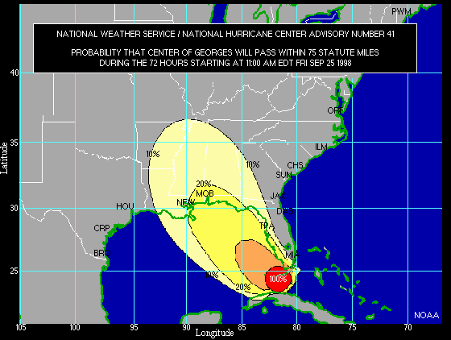
10) In the following text based probability chart, What is the probability of Hurricane Georges striking Panama City, Fl by 8 am Saturday Sept. 26, 1998 (please read the entire chart: pgs.8-9).
a) 3%
b) 17%
c) 24%
d) Don’t know
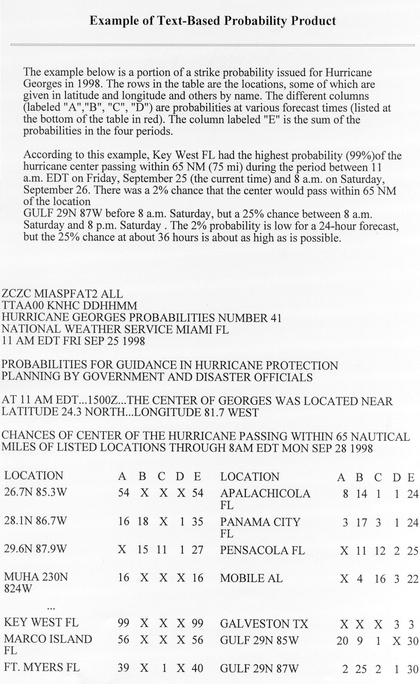

11) Do you prefer advisory A or advisory B (refer to advisories below)?

a). Advisory A
b) Advisory B
c) No Opinion
Please use the following area to make any comments on your reasons for your preference or any suggestions you have for inclusion in a storm surge advisory.
------------------------------------------------------------------------------------------------------------------------------------------------------------------------------------------------------------------------
------------------------------------------------------------------------------------------------------------
------------------------------------------------------------------------------------------------------------

Advisory A
…Storm Surge Flood and Storm Tide Impacts…1011 AM Wed Sep 15, 1999
Tide levels along the South Carolina and Georgia coasts are currently 1 to 3 feet above normal with heavy surf action. Beach erosion and dangerous rip currents are likely. The threat of coastal flooding and beach erosion will be high later today and tonight as Floyd approaches. Tides today through early Thursday are expected to run 3 to 5 feet above predicted levels along the Georgia coast with the maximum surge occurring around low tide this evening. For the South Carolina coast…Tides through early Thursday are expected to run 5 to 10 feet above predicted levels…with the maximum surge occurring closer to high tide
…Just after midnight…the highest tidal departures will occur near and to the right of landfall.
…Tide Information…
Charleston Beaufort Savannah
High 1236 PM Wed 148 PM Wed 1244 PM Wed
Low 644 PM Wed 743 PM Wed 654 PM Wed
High 1239 AM Thu 201 AM Thu 1257 AM Thu

Advisory B

1011 AM EDT Wed Sep 15 1999
Storm Surge and Storm Tide Impacts-
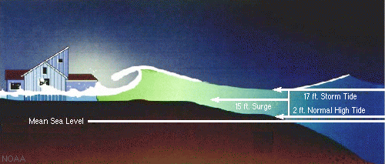
Note: The diagram above and the following text are general in nature and gives information for a storm surge generated by a Category 4 hurricane.
Currently tide levels along the South Carolina and Georgia coast are running 1-3 feet above normal due to the proximity of Hurricane Floyd, currently a category 4 storm. As Floyd nears the South Carolina coast early Thursday tides are expected to be 5-10 feet above normal and will coincide with high tide times. At 10 feet above normal residents of Folly Beach, SC should expect 5 feet of water in the first floor of the local Holiday Inn. At this height most of Folly Beach will be flooded. Roadways leading off the island will be impassable at this time because of high water levels.
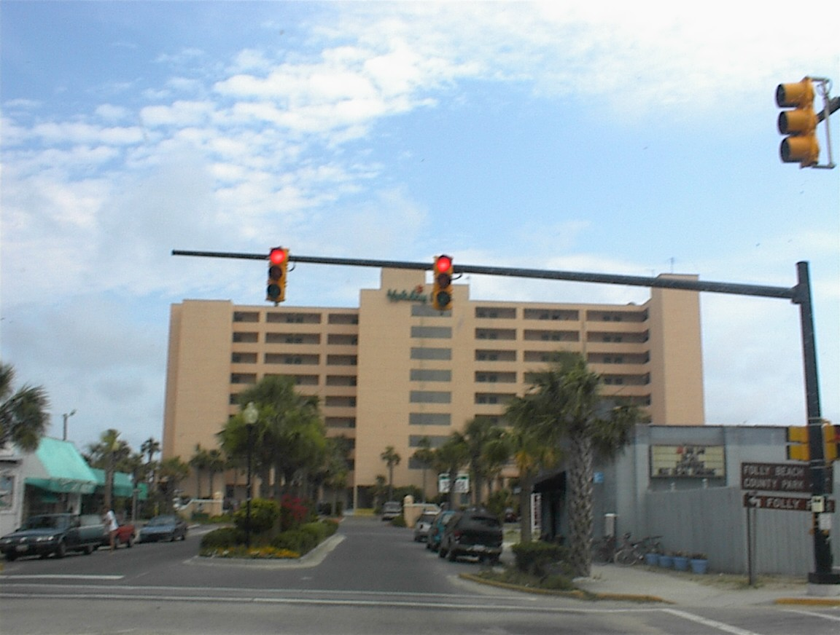
At City Hall on both Isle of Palms and Sullivan’s Island storm surge waters are expected to be 7 feet deep if current conditions remain constant. Under these conditions, the causeways leading from both islands will be impassable with 8 feet of water covering them. If you are on Folly Beach, Sullivan’s Island or Isle of Palms at this time you may be trapped in a potentially life threatening situation.
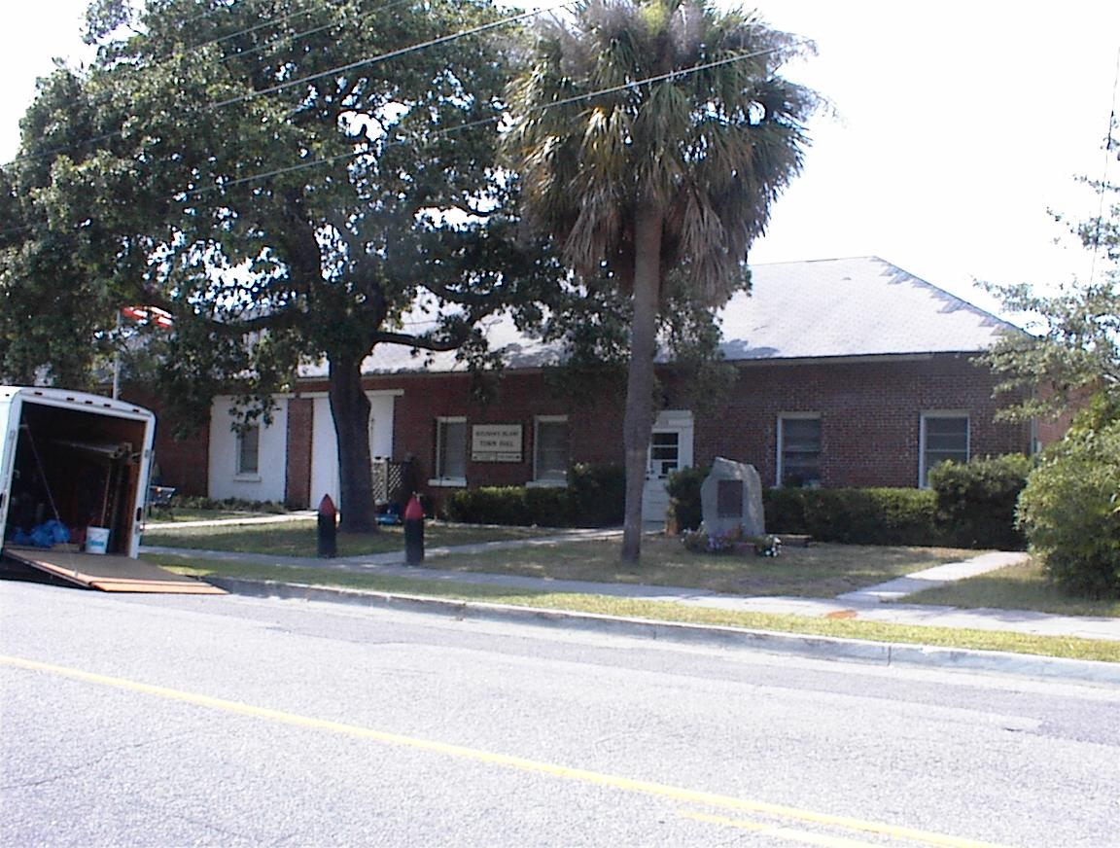
Sullivan’s Island City Hall
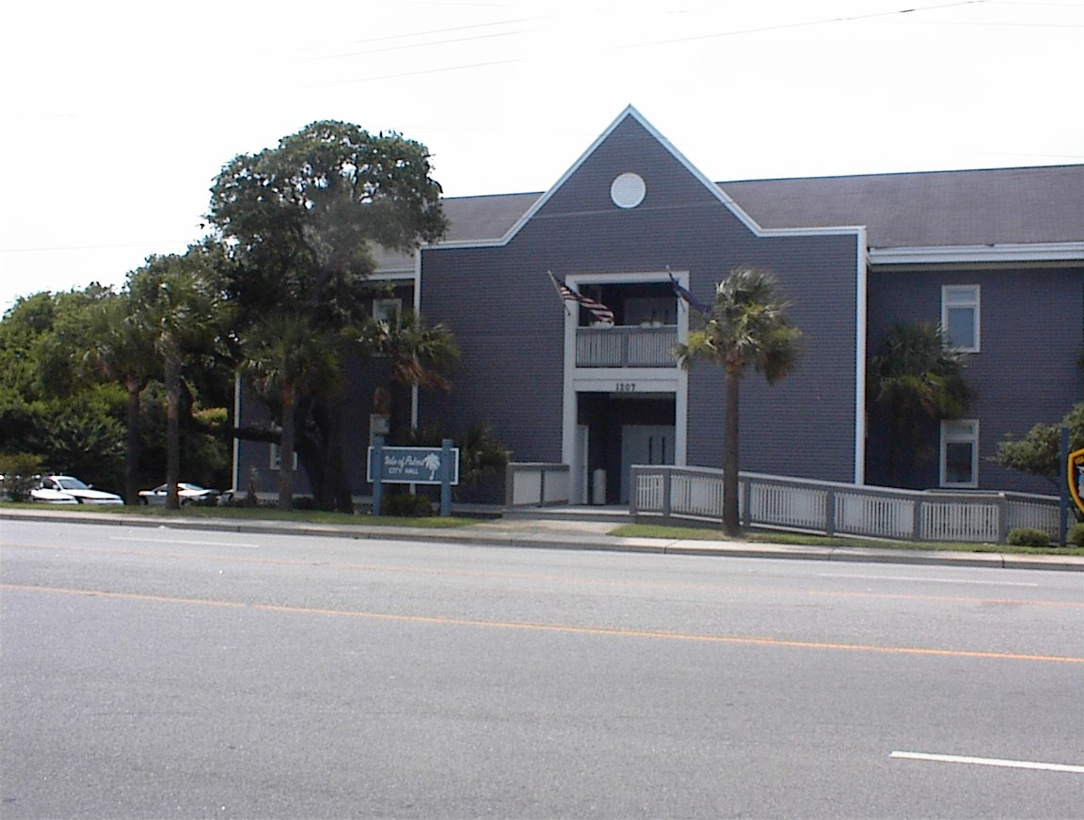
Isle of Palms City Hall
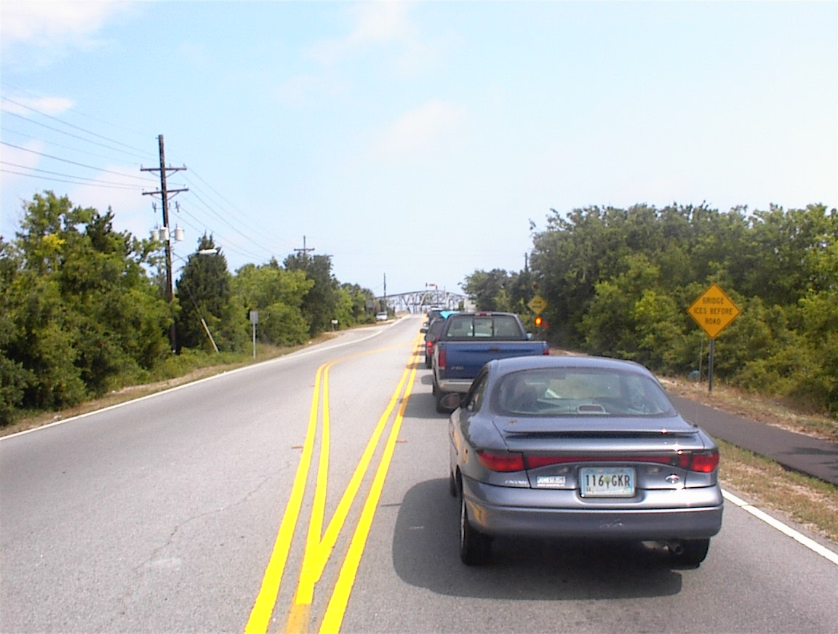
Hwy. 703 Causeway leading to the Ben Sawyer Bridge and Sullivan’s Island
In downtown Charleston White Point Gardens may be under 6 feet of water with the ground floor of Charleston City Hall experiencing 4 feet of water. Many of the roadways on the peninsula may also be flooded probably making any attempt at a late evacuation all but impossible.
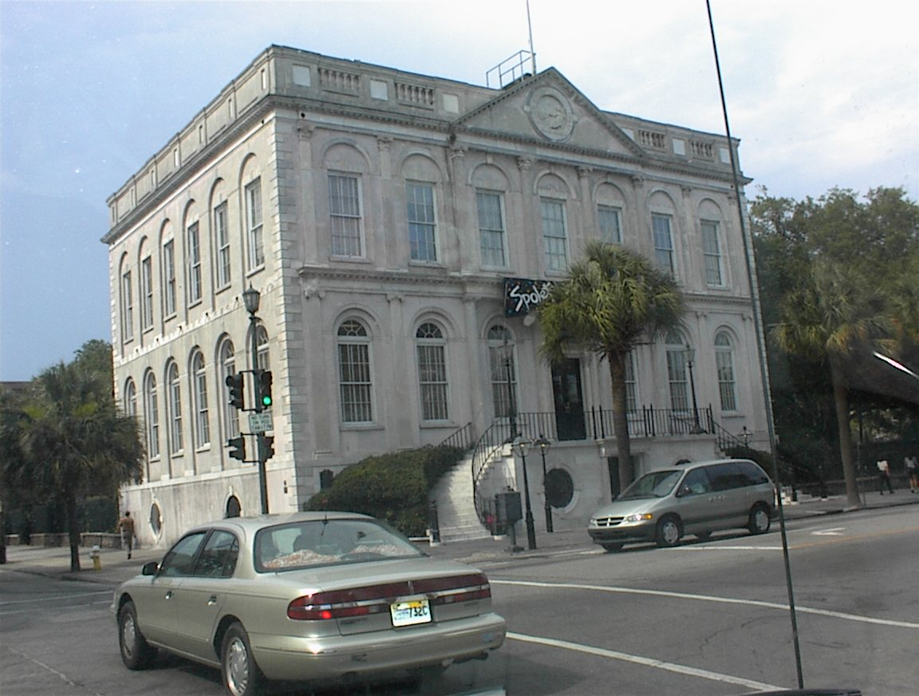
Charleston City Hall
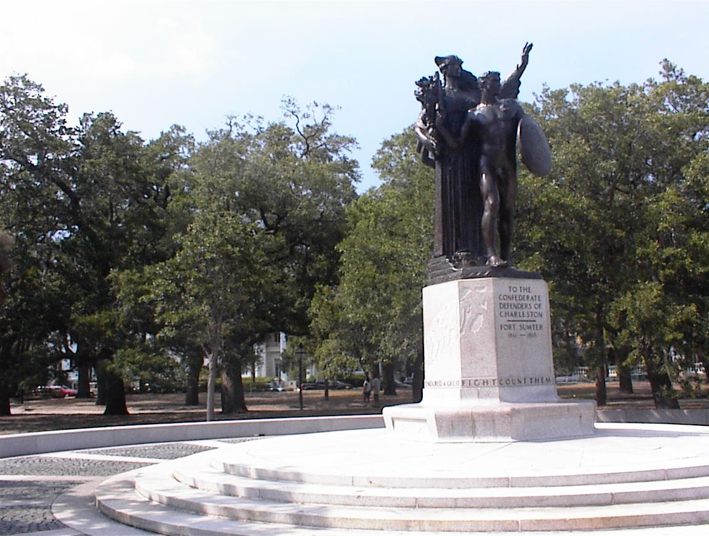
White Point Gardens
In addition to the storm surge induced flooding the above coastal areas can expect wind driven waves and heavy currents that may increase the damage to structures and add to the chance of human injuries or death.
Please be aware that historically more deaths are caused by storm surge than high winds or rain induced flooding.
12) Do you prefer Advisory A or Advisory B (refer to advisories below)?
a) Advisory A
b) Advisory B
c) No Opinion
Please use the following area to make any comments on your reasons for your preference or any suggestions you have for inclusion in a rainfall advisory.
------------------------------------------------------------------------------------------------------------------------------------------------------------------------------------------------------------------------------------------------------------------------------------------------------------------------------------------------------------------------------------------------------------------------------------------------
------------------------------------------------------------------------------------------------------------

Advisory A
…Rainfall…
…Occasional Rain…Heavy at times… Along with a few thunderstorms in outer bands will continue to affect the area through tonight. In South Carolina… locations close to the track of Floyd can expect 4 to 8 inches of rainfall…with locally higher amounts. Lesser amounts of 2 to 4 inches are possible across southeast Georgia.

Advisory B
Rainfall
Additional flooding can be expected from heavy rains associated with Hurricane Floyd. Based on the forecast forward speed of Floyd locations near the projected track of Floyd in SC can expect approximately 4-8 inches of rainfall from 10 PM Wed Sep 15 to 6 AM Thurs. Sep 16. This should produce a rise in rivers of approximately 3 feet that will cause additional flooding. Residents living in low-lying areas should consider evacuation.

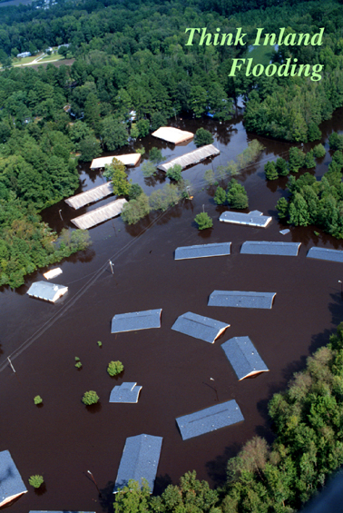
Inland flooding in NC due to rainfall from Hurricane Floyd- September 1999

13) Do you prefer format A or Format B (refer to the advisories below)?

a) Format A

b) Format B
c) No Opinion

Please use the following area to make any comments on your reasons for your preference or any suggestions you have for inclusion in a Hurricane Local Statement.
------------------------------------------------------------------------------------------------------------------------------------------------------------------------------------------------------------------------
------------------------------------------------------------------------------------------------------------

---------------------------------------------------------------------------------------------------------

Format A

Hurricane Local Statement
National Weather Service Charleston, SC
525 PM EDT Mon Sep 13 1999
…A Hurricane Watch is in effect from Savannah to Altamaha Sound…
Hurricane Floyd is moving toward the Georgia coast. The center of the storm is expected to be about 40 miles east of Savannah by late Wednesday afternoon.
This statement recommends specific actions that should be taken by the residents of the coastal counties of Georgia…Including Byan...Chatham…Liberty and McIntosh counties.
…Stock up on canned food…preferably food which can be eaten without cooking or heating. Power may be off several days to several weeks.
…Automobiles should be refueled.
…Check for adequate supplies of prescription drugs.
…Have workable flashlights or portable lanterns and a battery powered radio. Have a supply of spare batteries. Where possible…People should use battery powered lights and lamps instead of candles.

…Fill clean containers with water.
…Prepare Board up windows. Store or secure lawn furniture…Barbecue grills…Garbage cans…and other loose outdoor objects.
…Check mobile home tie-downs. Do not count on them for protection from severe wind damage. Prepare for evacuation when told to do so.
…Every household should have a plan of action when a hurricane threatens. If you don’t have one… Now is the time to formulate one. A plan allows you to act instead of react when an emergency arises.
Residents along the immediate coast should prepare to relocate further inland…preferably to homes of friends and relatives. Do not be alone during the storm.
When making your plan…you should give full consideration as to whether you should leave or stay if a warning is issued for your location.
A. If you live on a beach or barrier island…or have to travel across tidal flats to safety…plan to leave.
B. If you live in a mobile home…plan to leave.
C. If you live in an area, which has a history of flooding,…plan to leave.
D. If you live on high ground away from beaches and tidal marshes…and live in a sturdy home built to codes…consider staying in your home.

Format B
Hurricane conditions (winds above 74 MPH) are possible within the next 36 hours in the coastal Georgia area from Savannah to Altamaha Sound.
The center of Hurricane Floyd is expected to be 40 miles east of Savannah, Georgia by mid-afternoon Wednesday if conditions remain the same. Because many bridges are closed when winds reach 35 MPH evacuations from barrier islands should begin well before the arrival of these conditions, which should occur around 100 AM Wednesday September 15. NWS would like to stress that conditions will become extremely dangerous well before the arrival of hurricane force winds.
This statement recommends specific actions that should be taken by the residents of coastal counties of Georgia, including Bryan, Chatham, Liberty, and McIntosh Counties.
Every coastal household should have an evacuation plan that should include considerations such as:
1. The time required to evacuate from your location particularly if you live in areas served by bridges that may be closed as conditions worsen and/or in low lying areas that may be subject to flooding from storm surge and/or rain.
2. If you live in a mobile home consider evacuation.
3. If you live in a well-constructed house inland, on high ground that is not prone to flooding and has few large trees you may want to consider sheltering in place. Winds will be considerably diminished inland and if you live at heights above the predicted storm surge of 10 feet. Risk of flooding is then greatly reduced.
Other recommendations that should be considered are:
1. Obtain sufficient cash because power may be out following the hurricane. High winds and storm surges may damage power systems and access to cash may be limited following Floyd’s landfall.
2. Fill automobile gas tanks in order to facilitate evacuation because gas may be in short supply during a mass evacuation.
3. Stock up on non-perishable food that can be prepared without cooking since power could be off for some time after Floyd’s landfall. Food stores may also be damaged, limiting your access to food.
4. Fill all necessary prescriptions because damage from Floyd may limit the availability of normal services such as drug and grocery stores.
5. Store water for drinking in clean containers. Power outages and damages to water supply systems or water pumps may contaminate water.
6. Clear loose debris such as lawn furniture, grills and garbage cans from your property. They can become dangerous missiles in high winds. Note the results of wind born objects during Hurricane Andrew in the pictures below.
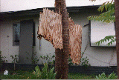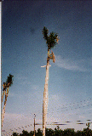
7. Shutter or cover windows with ½ inch plywood in order to limit damage by wind-born objects. Even small holes have been known to speed the destruction of homes.
8. Have flashlights, battery operated radio and spare batteries for both. If power is lost for a period of time you will need these to monitor news and to provide light during night hours. Avoid using candles that have been known to cause fires. Monitor Floyds progress on Television or radio. The NWS broadcasts Floyd updates on NOAA weather radio at the following frequencies: 162.4 MHz and 162.55 MHz.
14) Do you prefer advisory A or Advisory B? (See Advisories below)
a) Advisory A
b) Advisory B
c) No Opinion
Please use the following area to make any comments on your reasons for your preference or any suggestions you have for inclusion in a storm surge advisory.
------------------------------------------------------------------------------------------------------------------------------------------------------------------------------------------------------------------------
------------------------------------------------------------------------------------------------------------
------------------------------------------------------------------------------------------------------------

Advisory A
…Wind Information…
1011 AM EDT Wed Sep 15 1999
An inland high wind warning for hurricane force winds remains in effect tonight for Dorchester and Berkeley counties in South Carolina. An inland high wind warning for Tropical storm force winds is in effect for the following counties in southeast Georgia …Bulloch…Candler…Effingham…Evans…Jenkins…Long… Screven and Tatnall…and in South Carolina…Allendale…and Hampton. If Hurricane Floyd remains on its present course and speed…the storm will make landfall along the north coast of South Carolina around 2 AM Thursday morning. The present course will bring sustained tropical storm force winds of 40 MPH with higher gusts to coastal southeast Georgia and South Carolina just before noon. Tropical storm force winds will overspread the inland coastal counties this afternoon.
Hurricane force winds of 74 MPH or greater are expected to reach the central coast of South Carolina around 9 PM this evening. If the future track shifts to the west…Hurricane force winds would still be possible along the south coast of South Carolina.
A Tornado watch is in effect for the South coastal counties of South Carolina…and the adjacent coastal waters…through 10 PM tonight.

Advisory B
…Wind Information…
1011 AM EDT Wed Sep 15 1999
An inland high wind warning for hurricane force winds remains in effect tonight for Dorchester and Berkeley counties in South Carolina. An inland high wind warning for Tropical storm force winds is in effect for the following counties in southeast Georgia …Bulloch…Candler…Effingham…Evans…Jenkins…Long… Screven and Tatnall…and in South Carolina…Allendale…and Hampton. If Hurricane Floyd remains on its present course and speed…the storm will make landfall along the north coast of South Carolina around 2 AM Thursday morning. The present course will bring sustained tropical storm force winds of 40 MPH with higher gusts to coastal southeast Georgia and South Carolina just before noon. Tropical storm force winds will overspread the inland coastal counties this afternoon.
Hurricane force winds of 74 MPH or greater are expected to reach the central coast of South Carolina around 9 PM this evening. If the future track shifts to the west…Hurricane force winds would still be possible along the south coast of South Carolina.
A Tornado watch is in effect for the South coastal counties of South Carolina…and the adjacent coastal waters…through 10 PM tonight.
NWS recommends that if you live in these areas and have large trees such as pine trees or old weakened trees, you may want to evacuate to a safer location because these trees may fall and damage your house. Research has revealed that a house that has been damaged is much more likely to undergo catastrophic failure during high wind events.
The diagram below is an example of a graphical output of the information in the text above except it is for the Gulf Coast of the United States.
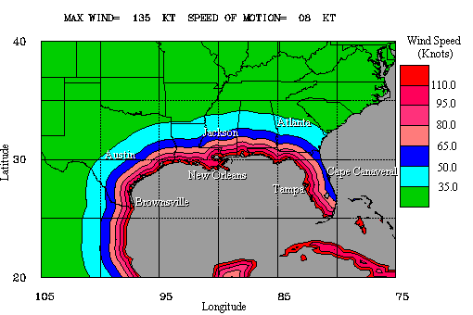
15) Would a graphical output of predicted wind speeds, as is shown in the previous question, help in your understanding of the dangers associated with winds from a hurricane?
a) Yes
b) No
c) Not Sure
Comments --------------------------------------------------------------------------------------------------------------------------------------------------------------------------------------------------------------------------------------------------------------------------------------------------------------------------------------------------------------------------------------------------------------------------------

Picture A below indicates 6 different model predictions for the future path of Hurricane Hugo in 1989.
Picture A

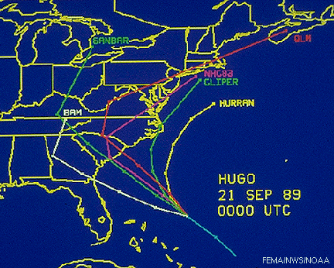

In the following picture, Picture B, the standard view for the projected track of a hurricane combines the predictions of the 6 models to yield an average predicted track. This is used to calculate a probability of landfall in the areas of concern.

Picture B
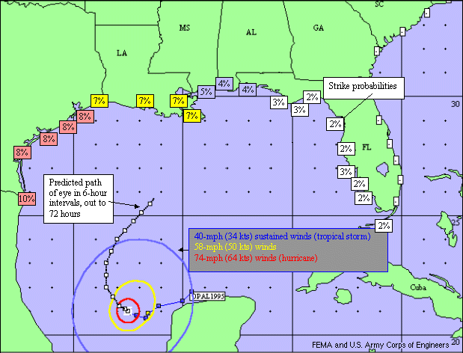
16) Which picture (from above), A or B, best represents the uncertainties involved with predicting the future track of a hurricane?
a) Picture A
b) Picture B
c) No Difference
Comments________________________________________________________________________________________________________________________________________________________________________________________________________________________________________________________________________________________________________________________
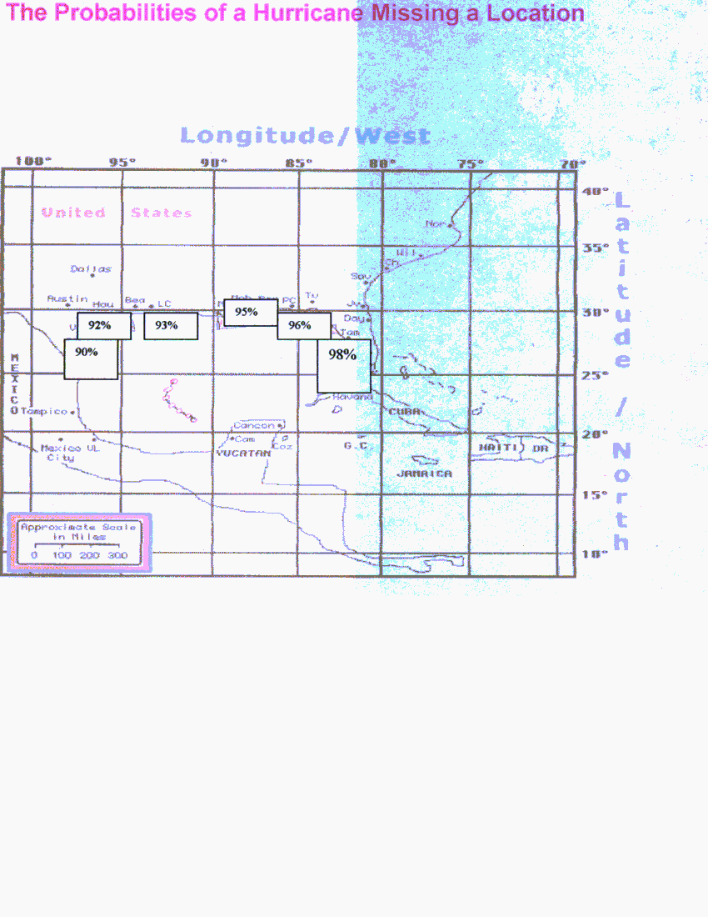
17) Would an alternative format in which the probability of a hurricane missing your location as opposed to striking your location help in your decision to evacuate/not evacuate? (Refer to above illustration)
a) Yes
b) No
c) Not Sure
Comments________________________________________________________________________________________________________________________________________________________________________________________________________________________________________________________

18) Project Impact is an initiative designed to assist communities in becoming more resistant to disasters. Charleston County and all of the municipalities within Charleston County participate in this initiative. Please rank the following general types of projects as to which you think would be most beneficial to you in preparing for a hurricane. Please use the following scale to rank each project.

[0→ Don’t Know, 1→ Unimportant, 2→ Moderately Important, 3→ Very Important]
____Distribution of printed information regarding preparation for a hurricane
____Presentations to groups (adult and/or children) about hurricane hazard mitigation
____Production/distribution of videotapes with “how-to” tips on preparation for hurricanes
____Providing demonstration models of structures showing hurricane resistant construction techniques
____Performing structural projects, such as but not limited to, drainage systems, roads, and/or utility service modifications
____Adopting ordinances requiring the use of hurricane resistant construction techniques
____Providing assistance to lower income property owners to perform retrofits for hazard resistance to their homes
____Training of contractors and/or design professionals on hurricane resistant construction techniques
____Training of real estate agents on ways to recognize structures that have been built to hurricane resistant standards
____Providing hurricane preparation/evacuation information on the Internet
Other suggestions you may have: ________________________________________________________________________________________________________________________________________________________________________________________________________________________________________________________________

